



Computer Vision

Home

About

Playlist

*COMPUTER*

M A C H I N E P R O B L E M N O . 1

*COMPUTER VISION*

*AND IMAGE PROCESSING*

Magpantay, Nino Jandel C. BSCS 4B

CSST106

Slide



1

# INTRODUCTION



Computer vision (CV) and image processing are two closely related fields that utilize techniques from artificial intelligence (AI) and pattern recognition to derive meaningful information from images, videos, and other visual inputs.



Read More

Slide



2

Image processing is at the helm of the technical revolution that is being called Industry 4.0, laying the framework for new technologies in image data processing and object recognition. Image processing algorithms are used to extract information from images, restore and compress image and video data, and build new experiences in virtual and augmented reality.

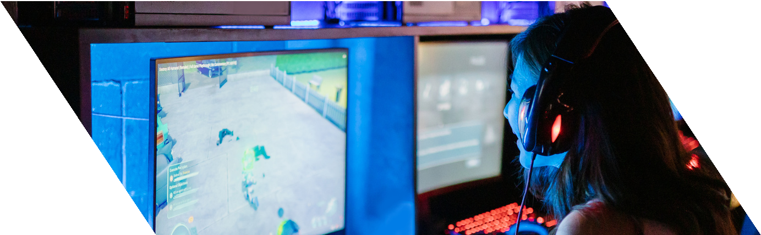

Slide



3



Read More

# HOW DOES VISUAL AI WORK?

Visual AI works by utilizing machine learning and deep learning algorithms to analyze visual data. It involves tasks such as image recognition, object detection, facial recognition, and scene understanding.



Slide



4

# ROLE OF IMAGE PROCESSING

**Improved Image Quality**

1

Image processing can enhance image quality, making images sharper, clearer, and more visually appealing.

3

**Information Extraction**

It enables the extraction of valuable information from images, which can be used for decision- making and analysis.

**Automation**

It allows for the automation of tasks that would be time- consuming and error-prone if done manually, such as object recognition or defect detection.

2

**Medical Diagnostics**

4

In the medical field, image processing aids in early disease detection and non-invasive diagnostics.





Slide 5

# ROLE OF IMAGE PROCESSING

**Enhanced Security:**

5

It enhances security through facial recognition, fingerprint analysis, and object tracking.

**Cost Savings**

7

It can lead to cost savings in various industries by reducing the need for manual labor and improving the efficiency of processes.

**Scientific Research**

Image processing is critical in scientific research, allowing researchers to analyze and visualize data effectively.

6

**Creative Expression**

8

In the arts and entertainment industry, it enables creative expression and the development of visually stunning effects.





Slide 6

## TYPES OF IMAGE PROCESSING TECHNIQUES

**Image Acquisition**



1

The process starts with acquiring an image using devices like digital cameras, scanners, or sensors. The quality and resolution of the acquired image are crucial.

3

**Image Enhancement**

Enhancement techniques aim to improve the visual quality of an image. These methods can sharpen edges, adjust brightness and contrast, and highlight certain features within the image.

**Preprocessing**

This stage involves cleaning up the image, removing noise, correcting distortions, and enhancing its quality. Common preprocessing techniques include image denoising, contrast adjustment, and image resizing.

2

**Image Restoration**

4 Restoration techniques are used to

recover or improve the original image from a degraded or damaged version.

This can be useful in scenarios such as

restoring old photographs or removing Slide 7

scratches and stains.

## TYPES OF IMAGE PROCESSING TECHNIQUES

**Image Segmentation**

5

Segmentation involves dividing an image into meaningful regions or objects. It is commonly used in object detection, medical image analysis, and more.

7

**Object Recognition**

Object recognition techniques are

used to identify and classify objects within an image. This is fundamental in applications like facial recognition, object tracking, and autonomous vehicles.

**Feature Extraction:**

In this step, relevant information is extracted from the image. This may include extracting specific patterns, shapes, or features for further analysis.

6

**Pattern Matching**

8

Image processing can be used to find patterns or templates within an image, which can be useful in various fields such as character recognition or fingerprint analysis.





8

Slide

*EXAMPLES*

# IMAGE ENHANCEMENT



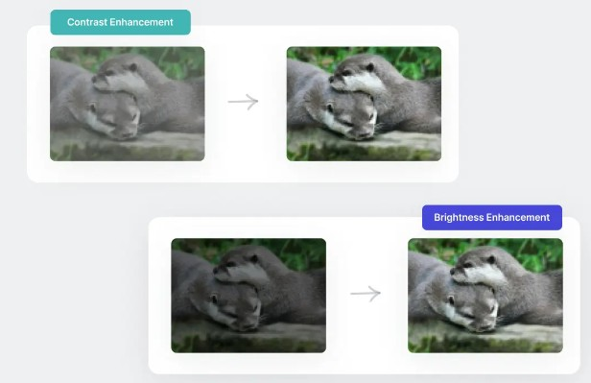 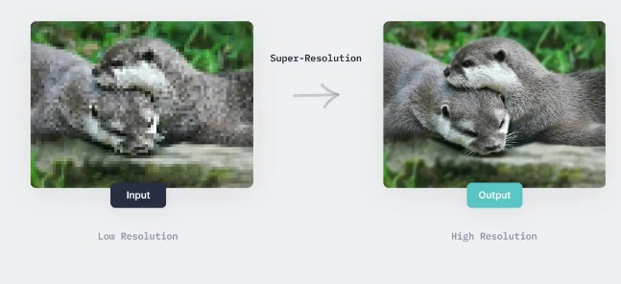

**Studio Shodwe** Slide



7

*EXAMPLES*

# IMAGE RESTORATION



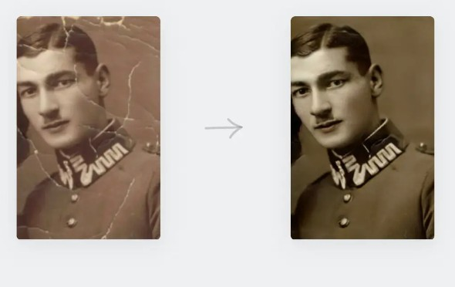

**Studio Shodwe** Slide



7

*EXAMPLES*

# IMAGE SEGMENTATION





**Studio Shodwe** Slide



7

*EXAMPLES*

# OBJECT DETECTION



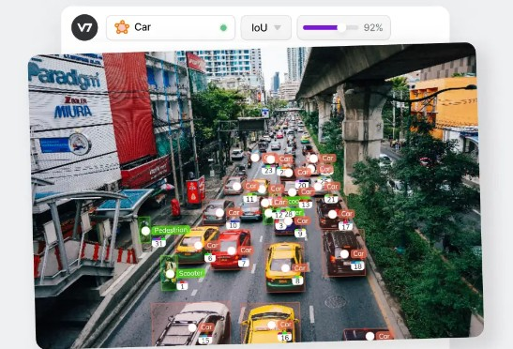

**Studio Shodwe** Slide



7

# CASE STUDY OVERVIEW

#### AUTONOMOUS VEHICLES

In autonomous vehicles, image processing is pivotal for enabling the vehicle to perceive its environment accurately. Cameras mounted on the vehicle capture real-time images of the road, which are then processed to extract meaningful information.

**Studio Shodwe** Slide



9

# CASE STUDY OVERVIEW

#### AUTONOMOUS VEHICLES IN THREE CORE TECHNIQUES

Filtering: Noise from various sources, such as lighting conditions and weather, can obscure important details in images. Filtering techniques help in enhancing these images, making features like lane markings and road signs more visible. For instance, Gaussian filters smooth out the image while preserving important structural details, aiding in the detection of lanes and obstacles.

**Studio Shodwe** Slide



9

# CASE STUDY OVERVIEW

#### AUTONOMOUS VEHICLES IN THREE CORE TECHNIQUES

Segmentation: Segmentation divides the image into different regions, allowing the system to categorize various parts of the scene, such as roads, sidewalks, vehicles, and pedestrians. This is critical for tasks like path planning, where the vehicle must decide where to drive based on the segmented regions of the road.

**Studio Shodwe** Slide



9

# CASE STUDY OVERVIEW

#### AUTONOMOUS VEHICLES CHALLENGES IT ADDRESSES

Real-Time Processing: Autonomous vehicles require real-time processing of images to make instantaneous decisions. Image processing techniques enable the rapid analysis of visual data, ensuring that the vehicle can react promptly to changing conditions.

**Studio Shodwe** Slide



9

# CASE STUDY OVERVIEW

#### AUTONOMOUS VEHICLES CHALLENGES IT ADDRESSES

Diverse Environmental Conditions: Autonomous vehicles must operate in various weather conditions, lighting situations, and environments. Image processing techniques help in normalizing these conditions, allowing the AI system to consistently recognize important features regardless of the external environment.

**Studio Shodwe** Slide



9

# CASE STUDY OVERVIEW

#### AUTONOMOUS VEHICLES CHALLENGES IT ADDRESSES

Object Detection and Classification: Detecting and classifying objects, such as vehicles, pedestrians, and road signs, is essential for safe navigation. Image processing enhances the system's ability to accurately identify and categorize these objects, reducing the risk of accidents.

**Studio Shodwe** Slide



9

# IMAGE PROCESSING IMPLEMENTATION

How the Model Works:

Input Image Preprocessing:

The model begins by capturing images from the vehicle's front-facing camera. These images are typically noisy due to varying lighting conditions, shadows, and reflections on the road surface.

**Studio Shodwe** Slide



9

# IMAGE PROCESSING IMPLEMENTATION

Grayscale Conversion:

The filtered image is converted to grayscale. This step simplifies the processing by reducing the image data to a single intensity channel, which is crucial for the subsequent edge detection process.

**Studio Shodwe** Slide



9

# IMAGE PROCESSING IMPLEMENTATION

Edge Detection:

The model employs the Canny edge detection algorithm to identify the edges in the grayscale image. This method detects significant transitions in intensity, which often correspond to the boundaries of lane markings on the road.

**Studio Shodwe** Slide



9

# IMAGE PROCESSING IMPLEMENTATION

Region of Interest (ROI) Selection:

Since lane markings typically appear within a specific region of the image (toward the bottom center), the model defines a region of interest (ROI) and masks out the irrelevant parts of the image. This step focuses the processing on the area where lanes are expected to be found.

**Studio Shodwe** Slide



9

# IMAGE PROCESSING IMPLEMENTATION

Hough Transform for Line Detection:

The edge-detected image within the ROI is then passed through the Hough Transform, which is used to detect straight lines corresponding to lane markings. This method converts the image space into a parameter space where each point represents a possible line in the image.

**Studio Shodwe** Slide



9

# IMAGE PROCESSING IMPLEMENTATION

Lane Overlay and Display:

The detected lanes are overlaid on the original image to provide a visual representation of the identified lanes. The final output shows the lanes highlighted on the road, enabling the autonomous system to understand its position relative to the lanes.

**Studio Shodwe** Slide



9

# IMAGE PROCESSING IMPLEMENTATION

How It Helps the AI System Solve the Problem:

Accurate Lane Detection: The model helps the AI system detect and track lanes on the road with high accuracy, even under challenging conditions like poor lighting or partially obscured lanes.

Real-Time Decision Making: By processing images in real time, the model provides the AI system with continuous feedback on lane positions, allowing for timely adjustments in steering and speed.

Improved Safety: Accurate lane detection is crucial for maintaining the vehicle's position on the road, preventing lane departures, and avoiding collisions. This model enhances the safety of autonomous driving by ensuring the vehicle stays within its designated lane.



9

**Studio Shodwe** Slide

# CONLUSION

Importance of Effective Image Processing in AI:

Image processing is essential in AI because it helps systems understand and make sense of visual information. By improving the quality of images, detecting important features, and dividing images into useful parts, AI can accurately interpret and respond to what it "sees." This is crucial in applications like self-driving cars, where understanding the environment quickly and accurately can make the difference between safety and danger.

**Studio Shodwe** Slide



9

# CONLUSION

Reflection on the Activity:

From this activity, I learned how important basic image processing techniques are in solving real-world problems. Building a model to detect lanes for autonomous vehicles showed me how each step— from reducing noise in images to detecting lane lines—plays a key role in helping AI systems work correctly. It taught me that effective image processing is vital for creating AI that can reliably and safely perform tasks in complex environments.

**Studio Shodwe** Slide



9

### EMERGING TECHNIQUE: DEEP LEARNING BASED IMAGE ANALYSIS

Introduction:

Deep learning-based image analysis is a new way of processing images using advanced AI techniques. Unlike older methods that use simple algorithms, deep learning uses complex models that learn from lots of data to understand and analyze images better.

**Studio Shodwe** Slide



9

### EMERGING TECHNIQUE: DEEP LEARNING BASED IMAGE ANALYSIS

Overview:

1. Convolutional Neural Networks (CNNs):

What It Is: CNNs are special AI models designed to recognize patterns in images. They learn automatically from the data, making them great at tasks like identifying objects or detecting features.

Impact: CNNs have greatly improved the accuracy of image analysis, helping with things like self-driving cars and medical image diagnostics.



9

**Studio Shodwe** Slide

### EMERGING TECHNIQUE: DEEP LEARNING BASED IMAGE ANALYSIS

Generative Adversarial Networks (GANs):

What It Is: GANs are made of two AI models that work against each other to create and improve images. One model creates images, while the other checks them for quality.

Impact: GANs can generate realistic images, improve image quality, and create new content, which is useful for creative projects and data generation.

Transfer Learning:

What It Is: Transfer learning uses a pre-trained AI model and adapts it to new tasks. It’s like reusing knowledge from one project to help with another.

Impact: This makes it faster and easier to train AI models for new tasks, even with

limited data, expanding the range of possible applications.



9

Slide

**Studio Shodwe**

### POTENTIAL IMPACT ON FUTURE AI SYSTEMS

Better Accuracy:

Deep learning models are very good at understanding images, leading to more accurate AI systems for things like driving safely or diagnosing diseases.

More Efficient:

These models can learn and adapt on their own, making them quicker and easier to use for different tasks without needing constant adjustments.

Creative Possibilities:

Techniques like GANs can create new and realistic images, which can be used for art, virtual reality, and more.

Easier to Customize:

Transfer learning allows for quick adaptation of AI models to specific needs, making it easier to create tailored solutions.

Slide



9

**Studio Shodwe**



### CONCLUSION

Deep learning-based image analysis is changing how we process and understand images. It offers more accuracy, creativity, and efficiency, making it a powerful tool for future AI technologies.

Slide



9

**Studio Shodwe**



### REFERENCES

https://[www.mccormick.northwestern.edu/electrical-](http://www.mccormick.northwestern.edu/electrical-) computer/academics/graduate/masters/specializations/computer-vision-and- image-processing.html#:~:text=Computer%20vision%20(CV)%20and%20image, videos%2C%20and%20other%20visual%20inputs. https://[www.lenovo.com/us/en/glossary/visual-ai/?](http://www.lenovo.com/us/en/glossary/visual-ai/) orgRef=https%253A%252F%252Fwww.google.com%252F https://[www.linkedin.com/pulse/what-image-processing-overview-applications-](http://www.linkedin.com/pulse/what-image-processing-overview-applications-) benefits/ https://[www.v7labs.com/blog/image-processing-guide](http://www.v7labs.com/blog/image-processing-guide) https://cgarbin.github.io/deep-learning-for-image-processing-overview/ https://[www.ncbi.nlm.nih.gov/pmc/articles/PMC7442218/](http://www.ncbi.nlm.nih.gov/pmc/articles/PMC7442218/)

Slide



9

**Studio Shodwe**



*THANK YOU*

**Studio Shodwe** Slide 10

